Title

An ant-dispersed plant community recovers following three-year removal of elaiosomes in a Connecticut forest

Author(s):

Robert Emerson Clark1,2

1Great Hollow Nature Preserve and Ecological Research Center

2EcoData Technology LLC

Corresponding email:

rclark@greathollow.org

Abstract:

Many species of plants exhibit a dispersal syndrome called myrmecochory, in which nutrient-rich seed appendages recruit ants which in turn transport seeds. This food-for-dispersal mutualism is common in the understory spring ephemeral and seasonal-green plant community found in temperate deciduous forests. In the Northeastern U.S. mixed deciduous forest ecoregion, a diverse assemblage of herbaceous plants are dispersed by the facultative mutualist ants *Aphaenogaster.* Since *Aphaenogaster* ants gain a significant nutrient subsidy from this mutualism, it is predicted that loss of these seeds could cause reductions in their population size. Forests in Connecticut (USA) are particularly impacted by urbanized development, but the myrmecochores that could be impacted by this land used changes are not well described. To address this shortcoming, I sampled multiple locations where myrmecochores were common. At a particularly intact site, I performed a long-term, small-scale removal of all elaiosomes-bearing diaspores in a gridded plot in a forest understory dominated by myrmecochores. From April to May from 2010 to 2012, all seeds were removed by hand from three 50m2 plots, each paired with control plots with no removal, and a supplementation plot with *Trillium erectum*. Following predictions of the life history of plants and ants in this system, I returned in Summer 2017 to collect data on proportional coverage of ant-dispersed plants and the abundance of seed-dispersing ants relative to the entire ant community. I found that despite entirely removing three growing seasons worth of elaiosomes, there were modest reductions in the proportional coverage of ant-dispersed plants. Ant communities were not impacted or had made a recovery within the 6-year duration of the experiment. In this experiment, evidence that *Aphaenogaster* were limited by elaiosomes was limited, supporting more recent research indicating that population densities are not constrained by the availability of myrmecochores. Consequently, I conclude that as long as surrounding populations of understory forest plants are maintained, both mutualistic ants and ant-dispersed plant communities have a robust ability to rebound from a reduction in this food source.

Introduction

Seed dispersal mutualisms are important components of terrestrial food webs since they represent a source of energy flow from plants to animals (citation). By providing a food source to animals in the form of fruit or seed tissue, plants can achieve directed dispersal to high-quality sites, while animal seed dispersers gain a critical food source (Farwig and Berens, 2012). A diversity of plants are ant-dispersed and present a syndrome of traits to recruit ant workers to seeds (Giladi 2006, Dunn et al. 2007). Myrmecochores are a diverse group of 11,000 species with this dispersal strategy that produce diaspores with soft, lipid-rich appendages called elaiosomes (Warren and Giladi 2014). Elaiosomes are particularly attractive to ants, and foraging workers return the seeds to the parent colony, remove the elaiosomes to feed to brood, and then discard the remaining seed to ant colony middens (Morales and Heithaus 1998). Elaiosomes contain multiple nutrients that can be limiting for ant colony development, including fats and amino acids (Fischer et al. 2005). High abundance of both ant-dispersed plants and ants in some habitats suggest this is an important limiting food source for ant colonies that increase ant population size. However, tests of this “dispersal mutualist limitation hypothesis” are limited (but see Warren et al. 2018). Related mechanistic work on the nutritional benefits of elaiosomes have focused on ant colony traits or fitness (e.g. Bono and Heithaus 2002, Clark and King 2012).

Myrmecochory is common in temperate forest understory plants following the spring ephemeral life history strategy and observed in North American and Eurasian deciduous forests (Gorb and Gorb, Boulay et al. 2007). These relatively small flowering plants have short leafing and flowering times, often completing emergence, pollination, and seed production before the forest canopy closes. In North American habitats, *Aphaenogaster* ants are numerically dominant, and evidence suggests these are the most effective dispersal mutualist for myrmecochores. *Aphaenogaster* ants rapidly discover and move diaspores, preventing seed predation by small mammals. Given the ubiquity of these ants, the “dispersal mutualist limitation hypothesis” has been primarily tested in this system (e.g. Warren et al. 2019). Under lab conditions, elaiosomes are a food source for *Aphaenogaster* colonies and can be particularly important when another insect prey is less available (Clark and King, 2012).

Demonstrating whether or not seed dispersing ants are limited by the availability of elaiosomes as a food source is an important question for the protection of this mutualistic community. Given the specificity of this mutualism, there is concern that habitat disturbance and fragmentation could negatively impact myrmecochorous communities or their seed-dispersing ants like *Aphaenogaster*. Myrmecochores in these systems are predominantly spring ephemerals and seasonal greens that are primarily found in intact closed-canopy mixed-deciduous forests. In smaller forest fragments, edge effects might drive reduced abundance of myrmecochores and seed-dispersing ants (Ness and Morin 2008). With the loss of these food sources due to habitat fragmentation, there could be cascading effects driving decline of this putative mutualist ant *Aphaenogaster*.

It is predicted that in areas where ant-dispersed plants dominate, removal of this mutualist could negatively impact *Aphaenogaster* populations if they are food limited. In the study area of this experiment (New Haven, Hartford, and Litchfield Co., Connecticut, USA), there is not a comprehensive list of ant-dispersed plants, nor any demonstration of their importance for maintaining populations of *Aphaenogaster*,nor the ability of this community to tolerate disturbance.

Methods:

*Surveys and description of Connecticut ant-dispersed plants*

I reviewed the literature on myrmecochorous plants, searching for species with known records in Connecticut forests. I queried Web of Science with the search terms “myrmecochor*”, “elaiosome*”, and “ant” + “dispersed” + “plant”. Reviewing the abstract, I verified if the study was about ant-dispersed plants and created a list of species found in studies conducted in eastern North America. With this species list, I queried the USDA plant range map database to see which species were located in the state of Connecticut. As a follow-up, I determined the number of records in the University of Connecticut Herbaria for these species.

In 2009-2010, I completed a range of surveys with volunteer students from Central Connecticut State University and University of Connecticut on ant-dispersed plant abundance in secondary forests. The locations, although not exhaustive, represent sites that were accessible and had reports from amateurs about high ant-dispersed plant abundance. The goal of these surveys was to provide preliminary data on the most common species found across a range of secondary forests typical to the state of Connecticut, and to find a location in which ant-dispersed plants numerically dominate the understory plant community. In order to test the hypothesis that mutualistic ants are limited by elaiosomes, it should be the case that high population densities of ants are found in areas where these are dense. Consequently, also, manipulation of the elaiosomes abundance should be expected to reduce the density of foraging ants or colony abundance.

*Small-scale disturbance trails at Henry Buck Trail*

We chose to the habitat manipulation at a site where all members of the myrmecochore complex easily found in Connecticut were present. We tested how small-scale disturbance to elaiosomes-bearing plants would impact the abundance of *Aphaenogaster* in an extremely high-density scenario. In a Connecticut forest, we designated plot in which ant-dispersed plants form 90% of the coverage of understory, non-woody plants and represent most of the diversity of herbs (data from supplemental figures?). In 2010, 2011, and 2012, I removed all apparent seedpods and flowers of ant-dispersed plant species in April-May each year (one visit each month). Given density estimates of April 2010 preliminary transects, we harvested over xxxx amount of flowers or seed pods (can I calculate this somehow?). In a third treatment, we supplemented plots with all *Trillium* seed pods that were extracted from removal treatments. *Trillium* has large, apparent seeds in which ants remove elaiosomes (personal observations, Gunther and Lanza 1989). *Trillium* supplementation was used as an opportunistic test if a single species can impact ant populations or if supplementation can change the coverage of *Trillium* long term.

Three years of elaiosomes removal deprived colonies located within these transects for a long-term period. The time period represents a long-term exclusion for this nutritional resource, and it would be difficult for *Aphaenogaster* in these plots to collect many elaiosomes given that their foraging territory is significantly small than the plots (Lubertazzi thesis reference). The six year period represents the time in which new colonies could be produced and develop given that it takes three to six years for incipient *Aphaenogaster* colonies to mature (citation from Lubertazzi thesis references).

*Statistical methods:*

Three approaches were used to statistical analysis in R version 4.0.5 (R working group, 2021). For analysis of proportional plant coverage at Henry Buck, I constructed a Generalized Linear Mixed Model (GLMM) using the lme4 package (Bates et al. 2015), and model estimates were extracted using the emmeans package (Lenth 2016). P-values for fixed effects were calculated using the car package (Fox and Weisberg 2011). To evaluate treatment effects on ant colony abundance, as measured by recruitment to baits, a Kruskal-Wallis rank test was employed due to the highly non-normal structure of these data (Ruxton and Beauchamp 2008). For analysis of species richness (estimated site-specific rarefaction) I used the vegan package (Osksanen et. al. 2019).

Results:

My literature and database search revealed there are 35 records of ant-dispersed plants in Connecticut ecosystems, 11 of which are putative reports based on non-native, exotic herbaceous plants. Several of the natural history reports describe the plants as ant-dispersed, but lack reported data on dispersal behavior, particularly reports for the non-native exotic species. Overall, this indicates there is a rich assemblage of ant-dispersed plants found in Connecticut ecosystems, and these are predominantly native spring ephemerals found in the regions mixed-deciduous forests. My surveys validated that many of these species can be common components of secondary forests in the states. The species richness and composition of the plant communities surveyed is reported in supplemental tables and figures S1-S4. Notably, line transects revleaed that the highest % cover of ant-dispersed plants was observed at the Henry Buck Trail at American Legion State Forest in Barkhamsted, CT (Fig S4).

Spring 2017 surveys of the plant community reveal a significant impact of historical removal on the proportional coverage of ant-dispersed plants in plots (Binomial GLMM, χ2 = 16.85, df = 2, *P* < 0.001). Control plots with no manipulation had the highest proportional coverage of ant-dispersed plants (Fig. 2, Tukey HSD). In terms of magnitude of this effect, 73.8% of the transects in control plots were covered by ant-dispersed plants, compared to 67.3% in removal plots, indicating they were still dominant in terms of leaf area. Plots with addition of *Trillium* seeds to plots had intermediate proportional covered by ant-dispersed plants (Fig. 2, Tukey HSD).

2017 baits used to record the ground-foraging ant community and *Aphaenogaster* colony abundance yielded five species of ants, including *Aphaenogaster rudis* group, *Camponotus pennsylvanicus*, *Lasius neoniger*, *Myrmica punctiventris,* and *Tapinoma sessile*. This sample event following three-years of myrmecochore removal and a six-year waiting period. We observed no difference in the abundance of seed-dispersing *Aphaenogaster* colony abundance among removal, control, or supplementation treatments (Fig. 3, Kruskal-Wallis, χ2 = 1.15, df = 2, *P* = 0.56). *Aphanogaster* workers were present at every observed bait in the removal treatment, additionally indicating they were abundant in these plots. Additionally, there was no difference among treatments in the recruitment of non-*Aphaenogaster* ants to these baits (Fig. 3, Kruskal-Wallis, χ2 = 0.78, df = 2, *P* = 0.67).

Discussion:

The impacts of human disturbance on dispersal mutualisms is a point of concern in the field of conservation biology (Markl et al. 2012). Specialized mutualisms are particularly susceptible to extinctions because if one partner is extirpated from an environment, the mutualistic partner risks demographic failure (Farwig and Berens, 2012). My results indicate that in intact forests, even fragmented habitats like those seen in the Northeastern U.S., ant-myrmecochore mutualisms have a robust ability to tolerate small scale disturbance. If three years of seed crop are lost to environmental upset, we observed that myrmecochores are still able to persist dominant member of the understory, herbaceous plant community. Conversely, large-scale disturbance that leads to forest lost, and then subsequent re-establishment, may require longer time scales for recovery of ant-dispersed plants (Sorrells and Warren, 2001). Supporting more recent work showing that *Aphaenogaster* are probably not elaiosomes-limited, I observed no change in the recruit of *Aphaenogaster* workers to baits during our sampling process.

My experiment is limited due to the geographic focus on a single forest system in Northeastern Connecticut. I intentionally chose a site where myrmecochore were abundant to test this hypothesis, but the impacts on *Aphaenogaster* for myrmecochore removal might be more severe in marginal habitats where myrmecochores are comparatively rare members of the understory plant community. For example, *Aphaenogaster* are less common on the edge of forest fragments as well as some of their plant mutualists (Ness and Morin, 2008). Furthermore, there is mounting evidence that climate change and larger-scale disturbances have profoundly negative impacts on mutualisms that require phenological matching (mismatch papers). Different ant-dispersed plants can stagger seed release throughout the season to avoid competition (Warren et al. 2014), a phenological pattern which could be disrupted by climate change if seed release and ant activity become asynchronous (Warren et al. 2010). While *Aphaenogaster* ants are resident arthropods in these environments, they may be depending on food sources arriving in the early spring when food sources can be scarce (Clark and King 2012), but this gap in food availability perhaps did not occur at the field site selected.

Mutualism specialization is an important topic in seed dispersal biology. While the myrmecochory seed dispersal syndrome shows clear specialization for recruiting and attracting ants, there is less evidence that *Aphaenogaster* or other seed-dispersing ants are specialist dispersers. A mutualism can still be specialized if one partner is a broad generalist (is this true, look up mutualism theory in Bronstein books). There is some argumentation that *Aphaenogaster rudis* is a keystone mutualist, required for dispersal of many myrmecochore species (Ness et al. 2009). Indeed, this could be the case as long as other generalist ant species are ineffective seed dispersers (need to find the paper on nonaphaenogaster dispersal). In all, this study indicates that while elaiosomes represent a large pulse of nutrients for ants, the likely only makes up a small portion of their incoming nutritional budget. Further work should investigate how changes to climate or large-scale disturbances might drive phenological mismatches or loss of *Aphaenogaster* from forest fragments.

Acknowledgements: I thank the staff at American Legion State Forest (Connecticut Department of Energy and Environmental Protection, Parks Division) for allowing me to tag and manipulate plants in Barkhampsted, CT. Josh King (University of Central Florida) provided guidance on the experimental plot layout. Multiple volunteers contributed to the laborious removal experiments, including Melissa Bernardo, Chris Berthiaume, Megan Clark, Joe McLaughlin, and Lauren Verner. Taiga Araki assisted with ant baits and ant-dispersed plant coverage surveys. Chad Seewagen (Great Hollow) and Vera Pfeiffer (Washington State University) provided helpful feedback on revisions of this manuscript.

References

Bates, D., Maechler, M., Bolker, B., Walker, S., (2015). Fitting linear mixed-effects models using lme4. J. Stat. Softw. 67, 1-48. <https://doi.org/10.18637/jss.v067.i01>

Bono, J.M., Heithaus, E.R., 2002. Sex ratios and the distribution of elaiosomes in colonies of the ant, Aphaenogaster rudis. Insectes soc. 49, 320–325. <https://doi.org/10.1007/PL00012655>

Boulay, R., Coll-Toledano, J., Manzaneda, A., Cerdá, X., 2007. Geographic variations in seed dispersal by ants: Are plant and seed traits decisive? Sci. Nat. 94, 242–6. <https://doi.org/10.1007/s00114-006-0185-z>

Clark, R.E., King, J.R., 2012. The ant, *Aphaenogaster picea*, benefits from plant elaiosomes when insect prey is scarce. Environ. Entomol. 41, 1405–1408. <https://doi.org/10.1603/en12131>

Dunn, R., Gove, A., Barraclough, T., Givnish, T., Majer, J., 2007. Convergent evolution of an ant-plant mutualism across plant families, continents, and time. Evol. Ecol. Res. 9, 1349-1362. <http://hdl.handle.net/20.500.11937/27347>

Farwig, N., Berens, D.G., 2012. Imagine a world without seed dispersers: a review of threats, consequences and future directions. Basic Appl. Ecol. 13, 109-115. <https://doi.org/10.1016/j.baae.2012.02.006>

Fischer, R.C., Ölzant S.M., Wanek W., Mayer V., 2005. The fate of *Corydalis cava* elaiosomes within an ant colony of *Myrmica rubra*: elaiosomes are preferentially fed to larvae. Insectes Soc. 52, 55-62.

Fox, J., Weisberg, S., 2011. An R Companion to Applied Regression. Sage Publications, Thousand Oaks, California.

Giladi, I., 2006. Choosing benefits or partners: a review of the evidence for the evolution of myrmecochory. Oikos 67, 334-344. <https://doi.org/10.1111/j.0030-1299.2006.14258.x>

Gunther, R.W., Lanza, J., 1989. Variation in attractiveness of *Trillium* diaspores to a seed-dispersing ant. Am. Midl. Nat. 122, 321–328. <https://doi.org/10.2307/2425919>

Lenth, R.V., 2016. Least-Squares Means: The R package lsmeans. J. Stat. Softw. 69:1-33.

Oksanen, J., Blanchet, F.G., Friendly, M., Kindt, R., Legendre, P., McGlinn, D., Minchin, P.R., B, R., O’Hara, G., Simpson, L., Solymos, P., Henry, M., Stevens, H., Szoecs, E., Wagner, H., 2019. vegan: Community ecology package. R package version 2.5-5. <https://CRAN.R-project.org/package=vegan>

Ness, J.H., Morin, D.F. Giladi, I., 2009. Uncommon specialization in a mutualism between a temperate herbaceous plant guild and an ant: Are *Aphaenogaster* ants keystone mutualists? Oikos 118, 1793-1804. <https://doi.org/10.1111/j.1600-0706.2009.17430.x>

Ness, J.H., Morin, D.F., 2008. Forest edges and landscape history shape interactions between plants, seed-dispersing ants and seed predators. Biol. Conserv. 141, 838–847. <https://doi.org/10.1016/j.biocon.2007.12.029>

Markl, J.S., Schleuning, M., Forget, P.M., Jordano, P., Lambert, J.E., Traveset, A., Wright, S.J., Böhning-Gaese, K., 2012. Meta-analysis of the effects of human disturbance on seed dispersal by animals. Conserv. Biol. 26, 1072–1081. <https://doi.org/10.1111/j.1523-1739.2012.01927.x>

Morales, M.A., Heithaus E.R., 1998. Food from seed-dispersal mutualism shifts sex ratios in colonies of the ant *Aphaenogaster rudis*. Ecology 79, 734-739. [https://doi.org/10.1890/0012-9658(1998)079[0734:FFSDMS]2.0.CO;2](https://doi.org/10.1890/0012-9658(1998)079%5b0734:FFSDMS%5d2.0.CO;2)

Ruxton, G.D., Beauchamp, G., 2008. Some suggestions about appropriate use of the Kruskal-Wallis test. Anim. Behav*.* 76, 1083-1087.

Sorrells, J., Warren II, R.J., 2011. Ant-dispersed herb colonization lags behind forest re-establishment. J. Torrey Bot. Soc. 138, 77–84. <https://doi.org/10.3159/10-RA-037.1>

Warren II, R.J., Bahn, V., Bradford, M.A., 2011. Temperature cues phenological synchrony in ant-mediated seed dispersal. Glob. Chang. Biol. 17, 2444–2454. <https://doi.org/10.1111/j.1365-2486.2010.02386.x>

Warren, R.J., Bradford, M.A., 2014. Mutualism fails when climate response differs between interacting species. Glob. Chang. Biol. 20, 466–474. <https://doi.org/10.1111/gcb.12407>

Warren II, R.J., Giladi, I., Bradford, M.A., 2014. Competition as a mechanism structuring mutualisms. J. Ecol. 102, 486–495. <https://doi.org/10.1111/1365-2745.12203>

Warren II, R.J., Giladi, I., 2014. Ant-mediated seed dispersal: A few ant species (Hymenoptera: Formicidae) benefit many plants. Myrmecological News 20, 129–140.

Warren II, R.J., Elliott, K.J., Giladi, I., King, J.R., Bradford, M.A., 2019. Field experiments show contradictory short- and long-term myrmecochorous plant impacts on seed-dispersing ants. Ecological Entomology 44, 30–39. <https://doi.org/10.1111/een.12666>

Figure captions:

Table 1. List of ant-dispersed plants found in Connecticut forests during 2010 sampling, natural history observations, and at Henry Buck Trail site. Status of verified seed dispersal syndrome highlighted in each row, along with description of observation status.

Fig. 1. Experimental design for Henry Buck Trail plots. Nine 50m2 plots were laid out in Spring 2009 and marked with GPS waypoints coordinates and flagged at corners. Arrow indicates cardinal orientation, and each panel describes the factorial treatment design. The asterisk indicates a single plant in which the overstory was dominated by *Pinus strobus* (White Pine) rather than a deciduous canopy.

Fig 2. Plot for binomial GLMM of % ant-dispersed plant cover out of all non-woody understory plants sampled (treatment as fixed effect, meter transects as random effects). Letters indicate post-hoc tests (Tukey HSD) across all treatment groups. Points indicate the estimated marginal means from the binomial GLMM and their associated error terms are represented by error bars.

Fig. 3. Violin plot for recruitment lines of workers found at baits in 2017 assay. Width of violin plots within each treatment indicates the relative number of counts of that number, while length indicates the range of observed outcomes (0-3 colonies per bait). Center points and error bars indicate mean and standard error of the mean.

Fig. 1.

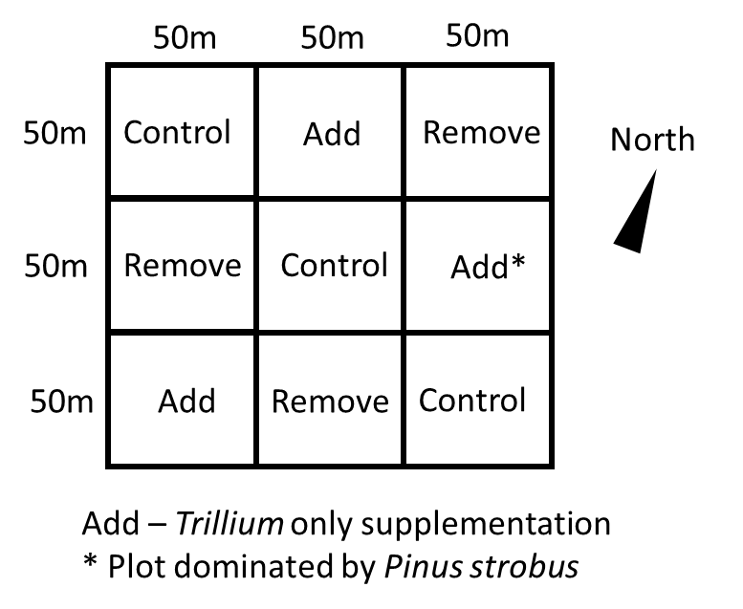

Fig 2.

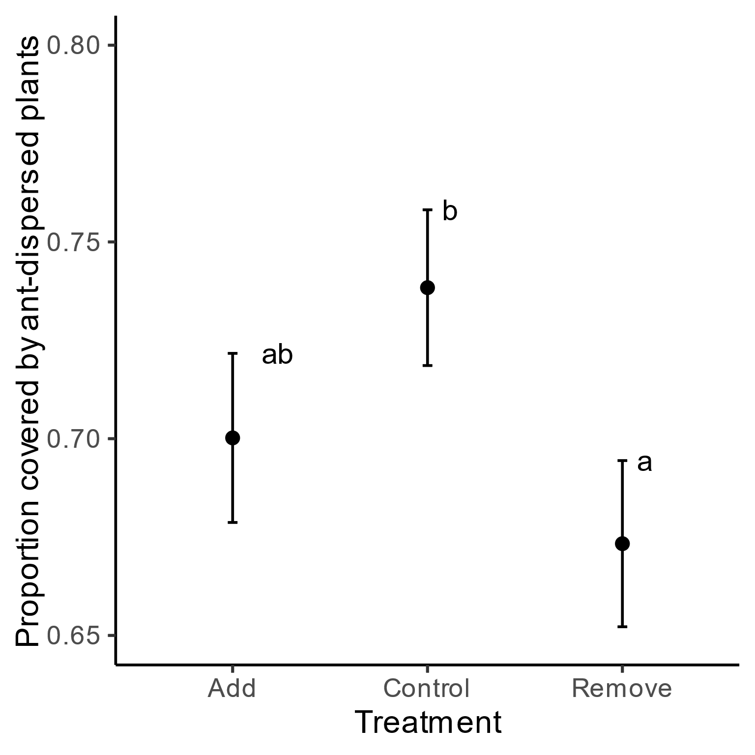

Fig. 3.

